**DMND0009566**

**Sim Registration CVM Communication Channels**

**PRJ0014023**

High Level Design Document

Version 1.0

Document Information

|  |  |
| --- | --- |
| **Software Version:** | **20.03** |
| Publication Date: |  |
| Catalog Number: |  |
| Information Security: |  |
| Created: | 12/4/2022 |
| Account/FOP: | PLDT |
| Author: | Eyal Bekerman |
| Editor: | Eyal Bekerman |
| Last Edited: | 12/15/2022 |
| File Name: | HLD DMND0009566 Sim Registration PRJ0014023 Inbox API v1.0.docx |
| Template: | Development.dotm |

Table of Contents

1 Introduction 5

1.1 Purpose and Scope 5

1.2 Related Documentation 5

1.3 Terms and Definitions 5

1.4 HLD Checklist 5

2 Requirement 7

2.1 Current Functionality 7

2.2 Reasons for Change 7

2.3 Business Impact 7

2.4 Business Value 7

2.5 Requirements Traceability Matrix 7

3 Overall Solution 9

3.1 Impacted Applications 9

3.2 Assumptions, Constraints and Dependencies 9

3.2.1 Assumptions 9

3.2.2 Constraints 9

3.2.3 Dependencies 10

3.3 Architecture Diagram 10

3.4 Use Cases 10

3.5 High-Level Solution 12

3.6 UI Changes 13

3.7 Fallout/Error Handling/Retry Mechanism 13

3.8 Effort Details 13

3.8.1 Overall Efforts 13

3.8.2 Scoping Efforts (Bucket A) 14

3.8.3 DCUT (Bucket A) 14

3.8.4 Breakdown of DCUT Efforts 14

3.8.5 Breakdown of Testing Efforts 15

3.9 Timeline 15

4 Other Impacts 15

4.1 Impacted Interfaces 15

4.2 Hardware/Third-party Software Impact 15

4.3 Impact on Performance 16

4.4 Impact on Operation 16

4.5 Impact on Security 16

4.6 Impact on Training 16

4.7 Impact on Migration 16

4.8 Impact on Production (System Downtime and Data) 16

5 Risks 17

6 Open Issues 18

7 Document Release Information 19

8 Appendix 20

8.1 Testing Scope 20

# Introduction

## Purpose and Scope

This project intends to support the sending of Sim Registration reminders to GL App Inbox.

## Related Documentation

|  |  |  |
| --- | --- | --- |
| **Document ID** | **Document Name** | **Author** |
| DOC-001 | Smart Solution Proposal | Smart |
| DOC-002 |  |  |
| DOC-003 |  |  |
| DOC-004 |  |  |

## Terms and Definitions

Following is a list of terms used in this document with which the reader should be familiar:

| Term | Definition |
| --- | --- |
| AD | Application Development |
| MS | Managed Services |
| POB | Performance Obligation |

## HLD Checklist

|  |  |
| --- | --- |
| **Items / Response** | **Response** |
| Portfolio | Smart Wireless and PLDT Home |
| Line of Business (LOB) | Wireless prepaid and Postpaid  Home |
| Impacted Brands | Smart Prepaid, Smart FLP, Smart Bro Prepaid, TNT, Retailer/Dealer/PD/RD/KA  Smart Postpaid, Smart Infinity  Ultera, Home Prepaid WiFi, Home Postpaid WiFi, PLP Prepaid and Postpaid, PLDT Smart BRO and GSM Postpaid |
| Audience / End User | Prepaid and Postpaid Subscribers  Home subscribers |
| Impacted System(s) | AIA |
| Vendor(s) | N/A |
| CSOG Required? | N/A |
| CRS / PPD Frozen | No |
| Mockup’s Shared? | Not Applicable |
| Spiels Shared? | Not Applicable |
| Capacity Assessment | Pending traffic projection c/o Smart |
| Transformation Impact | None |

# Requirement

## Current Functionality

No SIM registration process in place yet.

## Reasons for Change

Support GL App inbox as touch point for sim registration reminders.

## Requirements Traceability Matrix

Below are the use cases in the scope of Assessment of this Demand. The RTM table below indicates their coverage from solution assessment point of view.

|  |  |  |  |  |  |  |
| --- | --- | --- | --- | --- | --- | --- |
| **Unique ID** | **Description** | **Proposed Solution** | **GA / RISK / CONSTRAINT and DEPENDENCIES** | **Use Case** | **Impacted System** | **Remarks** |
| REQ-001 | AIA to Push Sim Registration Reminder Notification via GL App | PS-001 |  | UC-001 | AIA |  |

# Overall Solution

## Impacted Applications

|  |  |
| --- | --- |
| **Affected Systems** | |
| AIA |  |
|  |  |
|  |  |

## Assumptions, Constraints and Dependencies

### Assumptions

|  |  |
| --- | --- |
| **Unique ID** | **Description** |
| GA-001 | Any other new changes not stated in this document upon HLD approval shall require a new demand and shall be covered in a separate HLD. |
| GA-002 | There is no new report requirement scoped in this document. |
| GA-003 | Testing scope indicated under section 8.1 shall be considered as final upon HLD approval. |
| GA-004 | Spiels shall be configured in AIA by Smart Business user. |
| GA-005 | Trigger name/events shall be configured in AIA by Smart business user |
| GA-006 |  |
| GA-007 |  |

### Constraints

|  |  |
| --- | --- |
| **Unique ID** | **Description** |
| GC-001 | Prioritization of ongoing projects |
| GC-002 | Interface readiness |
| GC-003 | Force majeure situations |
| GC-004 | HLD timelines shall be provided based on the new prioritization process |
| GC-005 | Timeline shall be declared after the HLD approval |

### Dependencies

|  |  |
| --- | --- |
| **Unique ID** | **Description** |
| GD-001 |  |

## Architecture Diagram

### UC-003

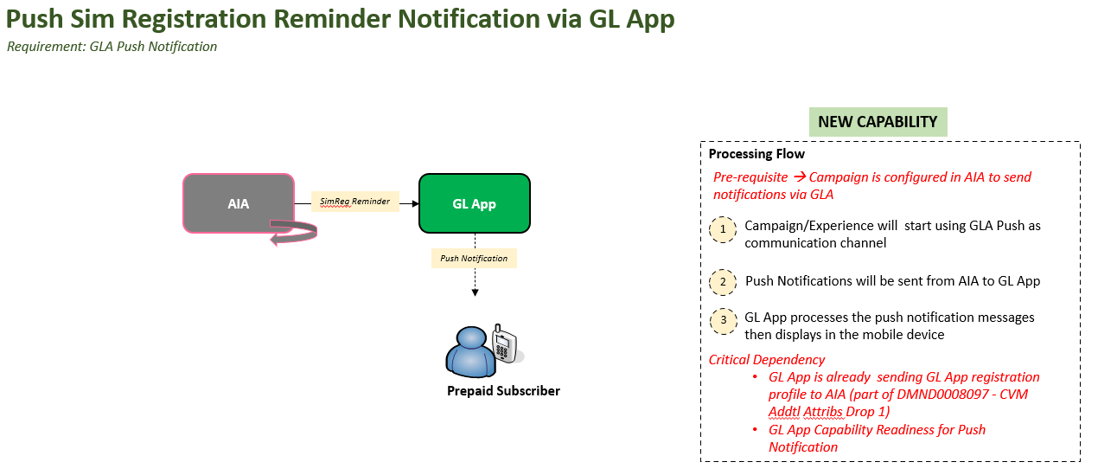

## Use Cases

Here is the summary of use case scenarios:

|  |  |
| --- | --- |
| **UC ID** | **USE CASES (UC)** |
| UC-001 | * Push Sim Registration Reminder Notification via GL App |

## High-Level Solution

Here is the summary of proposed changes:

| **PS ID** | **Proposed Solution (PS)** |
| --- | --- |
| PS-001 | Changes in AIA   * Support a new outbound communication/message type – GL App Inbox * The new message will support a fixed number of dynamic parameters (which are pre-defined per template on GL App BE) * Integrate with GL App for the purpose of sending inbox messages |

## Fallout/Error Handling/Retry Mechanism

In any case of failure while sending messages to GL App BE, solution will support configurable number of retries and retry interval.

## Effort Details

### System Work Effort

| **System** | **Work Effort** | **Man-Days** | **Remarks** |
| --- | --- | --- | --- |
| AIA | * RT Changes - 2 MD * Development for new outbound communication message type - 11 MD * Unit Test - 3 MD * RPM for SIT - 2 MD | 18 |  |
| TESTING | SIT: Testing for new outbound communication type  IAT: E2E Testing for above scenarios  BUAT: Data preparation for biz testing  PPT Support: Sanity validation post deployment | 6 |  |

### Total DCUT and Testing Effort

|  |  |  |
| --- | --- | --- |
| **Project Execution Items** | **Actual Effort** | **Remarks** |
| Development and Unit Testing (DCUT) | 18 |  |
| Total Testing Effort | 6 |  |
| **Total Effort** | **24** |  |

### Overall Efforts

|  |  |  |
| --- | --- | --- |
| **Project Execution Items** | **Actual Effort** | **Remarks** |
| Development and Unit Testing (DCUT) | 18 | **AIA-GLApp Push notification-18 MD** |
| Scoping, Impact Assessment and High Level Design | 5 |  |
| System Acceptance Testing (SAT) | 6 |  |
| SAT Application Support | 3 |  |
| Integration Acceptance Testing (IAT) | 3 |  |
| IAT Application Support | 2 |  |
| User Acceptance Testing (UAT) - data prepration | 2 |  |
| UAT- Operational support | 1 |  |
| UAT - Application Support | 3 |  |
| Quality and Release Management | 2 |  |
| Project Management | 3 | **Estimated project management effort** |
| Post Production Test (PPT) | 1 |  |
| PPT Application Support (*) | 1 |  |
| Production Stabilization | 1 |  |
| Ongoing Maintenance | 1 |  |
| E2E Testing (*) | 0 |  |
| E2E Testing Application Support (*) | 0 |  |
| Performance Testing (*) | 0 |  |
| Performance Testing Application Support (*) | 0 |  |
| Regression Testing (*) | 1 |  |
| Regression Testing Application Support (*) | 1 |  |
| CSOG Governance Support (*) | 0 |  |
| CSOG Execution Support (*) | 1 | **CSOG scan support effort** |
| Staging Deployment / Integration Support (*) | 0 |  |
| Other Effort (*) | 0 |  |
| **Total Effort** | **55** |  |

## Timeline

Timeline shall be provided upon HLD approval.

# Other Impacts

## Impacted Interfaces

Not applicable

## Hardware/Third-party Software Impact

Not applicable

## Impact on Performance

Pending traffic projection

## Impact on Operation

Not applicable

## Impact on Security

Not applicable

## Impact on Training

Not applicable

## Impact on Migration

Not applicable

## Impact on Production (System Downtime and Data)

Implementation shall require Regular Deployment.

# Risks

| Item | Risk | Impact Severity | Mitigation / Solution | Owner | Status | Comments |
| --- | --- | --- | --- | --- | --- | --- |
|  |  |  |  |  |  |  |
|  |  |  |  |  |  |  |

# Open Issues

| Open  Item | Impact | Type of Open Item | Owner | Status | Due Date | Comments |
| --- | --- | --- | --- | --- | --- | --- |
| 0I-001 | HIGH | Pending USSD Menue | Smart | Pending |  |  |
|  |  |  |  |  |  |  |
|  |  |  |  |  |  |  |
|  |  |  |  |  |  |  |

# Document Release Information

Every change made to the document following the initial delivery MUST be shown in detail in this table

| SW Ver. | Editor/Author | Application | Edit Date | Section / Changes | Approving Manager | Version |
| --- | --- | --- | --- | --- | --- | --- |
| V 1.0 | Humprey Ramirez |  | 11/17/2022 | Initial draft |  | V 1.0 |
|  |  |  |  |  |  |  |
|  |  |  |  |  |  |  |
|  |  |  |  |  |  |  |
|  |  |  |  |  |  |  |
|  |  |  |  |  |  |  |

# Appendix

## Testing Scope